## 13.06.23

## 3pm – 5pm

## The Ilfracombe Centre

# Meeting Notes

|  |  |
| --- | --- |
| **In attendance** | **Organisation** |
| Sheena Asthana | Plymouth University |
| Sheela Agarwal | Plymouth University |
| Andrea Beacham | One Ilfracombe, One Northern Devon, Royal Devon University Healthcare Trust |
| Paul Crabb | One Ilfracombe, Ilfracombe Town Council, North Devon Council, Devon County Council |
| Martin Barnard | Devon County Council |
| Richard Preston | Devon & Cornwall Police |
| James Lander | One Northern Devon/Royal Devon University Healthcare Trust |
| Charlotte Pavitt | DCC Public Health |
| John Thornton | One Ilfracombe/Ilfracombe Town Council |
| Charmain Lovett | One Ilfracombe, Ilfracombe Town Council |
| Ken Miles | North Devon Council |
| Marc Rostock | North Devon Homes, One Ilfracombe, One Northern Devon |
| Oliver Hassall | One Northern Devon/NHS Devon/Primary Care |
| Steve Cronin | Ilfracombe Academy |
| Richard Blackwell | South West Academic Health Science Network |
| Simon Chant | Devon County Council |
| Simon Kitchen | Devon County Council |
| Rod Donovan | One Ilfracombe, Ilfracombe Town Council |
| Sarah-Jane Mackenzie-Shapland | North Devon Council |
| Steve Seatherton | One Ilfracombe, Ilfracombe Town Council |
| Laura Donovan | Ilfracombe Town Council |

|  |  |
| --- | --- |
| **Apologies** | **Organisation** |
| Kay Brennan | NHS Devon |
| Becky Harty | NHS Devon |
| Toby Davies | Devon & Cornwall Police |
| Daniel Turton | Ilfracombe Town Council |
| Rob Whitney | Ilfracombe Academy |
| Neil Ingram | One Ilfracombe, Ilfracombe Town Council |

## Setting the scene

Cllr Crabb welcomed everyone to the meeting and the reason for the meeting was discussed in that Ilfracombe continues to have some of the worst deprivation statistics in the country and partners had agreed a renewed effort was needed to shift the dial. It was agreed that ‘levelling up’ had a political connotation and another name would be agreed.

It was acknowledged that much has been done and continues to be done in Ilfracombe and that there was a need to build on this good work, not duplicate it and importantly to understand the impact of the work and if the expected impact hasn’t been achieved, the reasons for this. It was discussed that this group should focus on what it can create that wouldn’t otherwise be created.

Andrea Beacham introduced the Double Diamond design framework as a helpful tool when trying to address complex issues. The first stage of the framework is to gather as much insight into the problem (which can be further defined at a later stage) from a variety of perspectives and sources – in particular those affected. It was felt that this stage could potentially be a desk exercise as so much was already known and lots of engagement had already been carried out.

It was agreed that it was important to get a better understanding of the work that has been done over the past 10 years and if any of it has made a significant difference to the statistics of Ilfracombe and if not, why not.

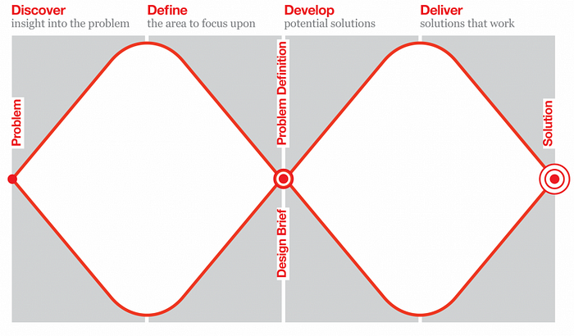

## Discovery stage – what do we know and what have we learnt about Ilfracombe?

Simon Chant highlighted some of the latest statistics for Ilfracombe from the Census 2021 data:

<https://www.ons.gov.uk/visualisations/customprofiles/draw/>

with some of the following examples:

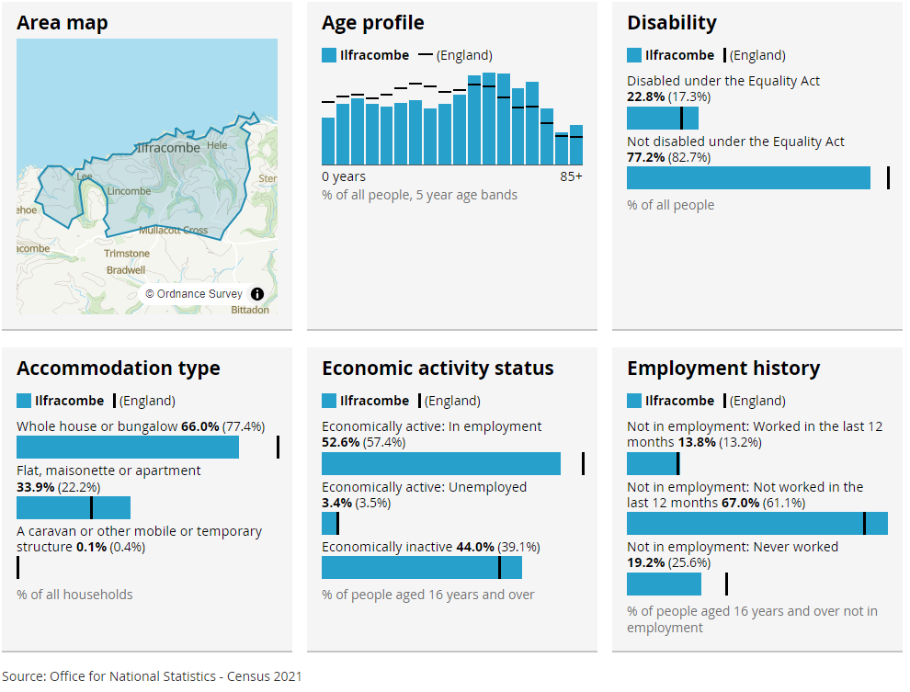

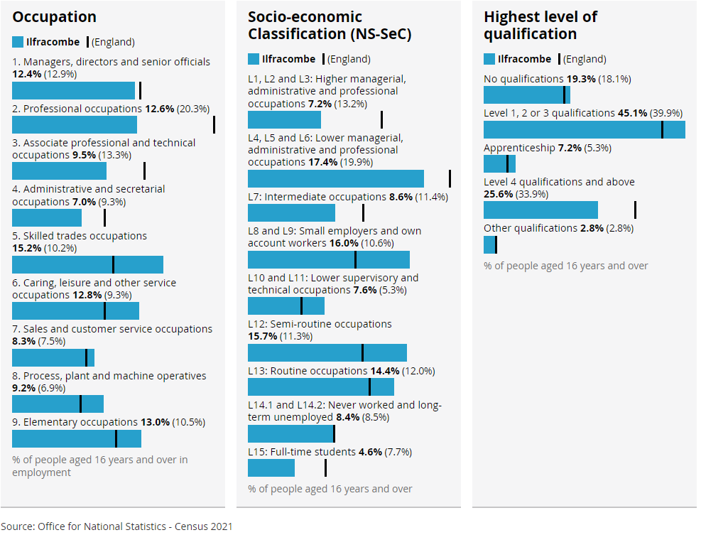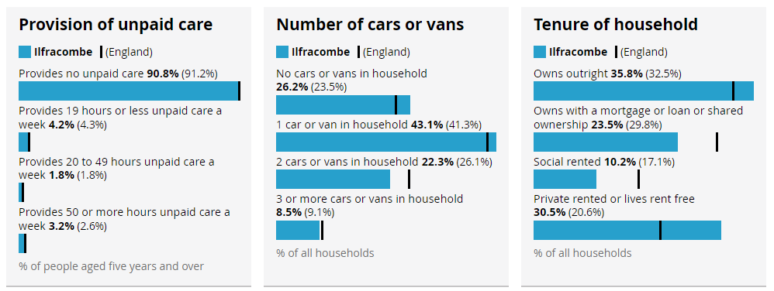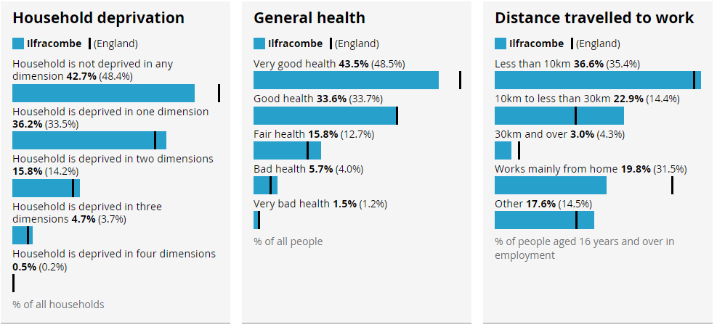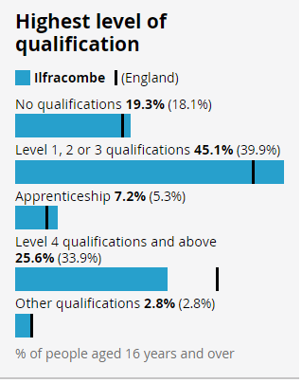

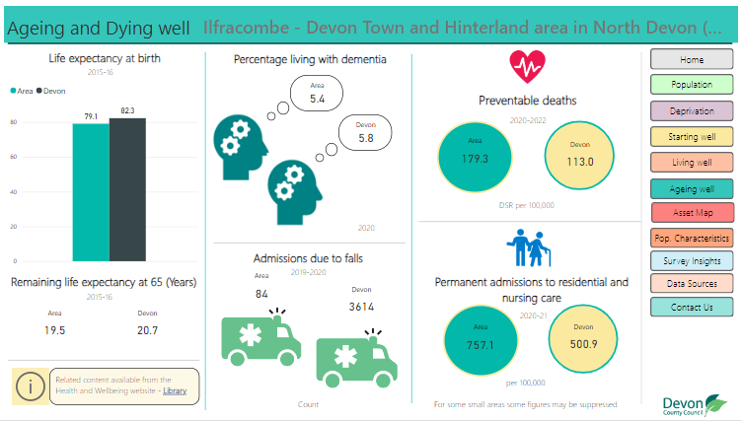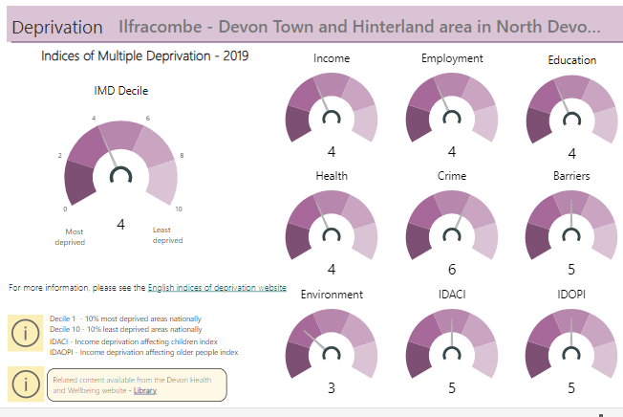And from Devon County Council’s Joint Strategic Needs Assessment: <https://www.devonhealthandwellbeing.org.uk/jsna/jsna-headline-tool/>

And the 2021 Census Map Tool – where you can select different census indicators on the left hand side and zoom in and out of the map to reveal more local differences, eg:

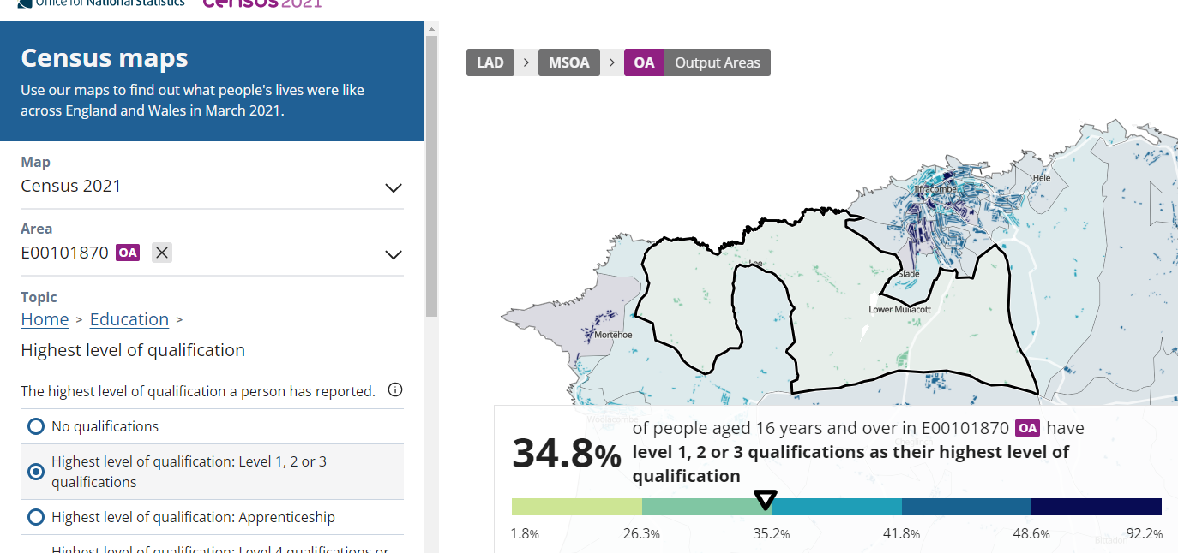[Highest level of qualification - Census Maps, ONS](https://www.ons.gov.uk/census/maps/choropleth/education/highest-level-of-qualification/highest-qualification-6a/no-qualifications)

Richard Blackwell presented data focussing on the Indices of Multiple Deprivation (IMD) which is a measure of relative deprivation at a small local level. The components it measures are:

* 1. Income
  2. Employment
  3. Education & Skills
  4. Health
  5. Crime
  6. Barriers to housing and services
  7. Living environment

Richard showed that some of the indices had improved in some of the areas, some had gone down but looking at it in overview, the IMD has remained fairly constant over the three data points: 2005, 2010, 2019

## Current opportunities

**LPIP**

Sheena Asthana and Sheela Agarwal gave some background on the opportunity with the South West Coastal Local Policy Innovation Partnership (LPIP) which has been awarded some initial stage 1 funding to investigate key inequalities facing the South West and how they might be addressed. Proposals will be submitted in September and there is an opportunity to include some ‘place-based’ projects which, if successful would receive funding to develop, test and implement approaches alongside the research and evaluation expertise brought by the academic partners.

Currently, the team are collecting evidence from existing consultations and collating a repository of potential projects followed by a series of stakeholder workshops.

This group has the opportunity to co-create a place-based proposal as well as have involvement in the other relevant themes.

[Current LPIP starter-for-ten project proposal themes](https://www.plymouth.ac.uk/research-and-expertise/centre-for-coastal-communities/shaping-our-research-priorities):

* Cross-cutting themes
  + Evaluating and capturing the learning around the work of community assets
  + Addressing policy complexity through a Human Learning Systems approach
* Inclusive and sustainable economy
  + Digital Innovation and Skills
  + Housing affordability
* Strengthening and connecting communities
  + Levelling up education and social mobility on the coast
  + Improving the mental health of children and young people on the coast
  + Marine Citizenship and the Social and Economic Benefits of Coastal Heritage
  + Making the coast accessible and beneficial to all
* Living and working sustainably in a greener economy
  + Mitigating Climate Change: Co-Production and Place
  + Unlocking marine innovation
  + Sustainable food systems and communities

**ACTION:**

* Existing consultations, strategies, insights on Ilfracombe to be sent by all partners to Steve Seatherton. Charmain/Neil to send previous engagement data to Steve.
* Steve to create repository of data and send to Naomi Tyrrell
* Naomi to help collate and draw out key findings (which can also be used for the LPIP)
* Group to agree what we would put in a place-based proposal. Is there a particular focus that we would like to explore further? Given that everything is interlinked and much of it is interdependent, is there a particular entry point we’d like to use?
* To agree what the highest impact areas
* To agree what the common drivers are

**Poverty Truth Commission**

It was suggested that the Poverty Truth Commission that we are due to launch in the next couple of months could be focussed on Ilfracombe to ensure the voices of those most affected by the inequalities that exist in the town are fully involved in the process.

**ACTION:**

* Andrea to take this suggestion to the OND board and confirm with the commissioner and the PTC team.

**Population Health Management**

The One Devon Dataset was not available when One Ilfracombe was first established in 2013 and it was agreed that this and the Population Health Management approach would be a useful tool to identify key issues and the groups of people we could focus our efforts with.

It was questioned whether any of the approaches or opportunities compete/confuse matters but the PHM approach maps very well into the double diamond:

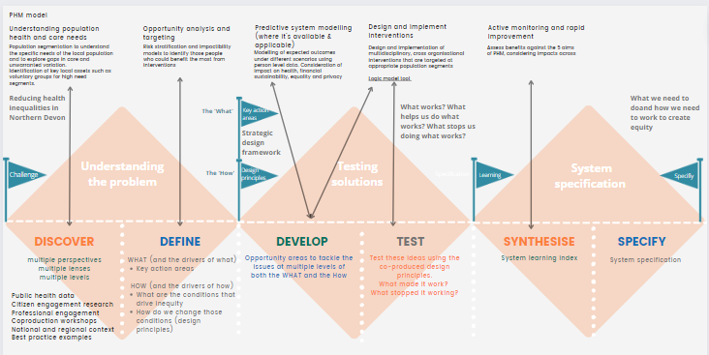

And both the LPIP and Poverty Truth Commission fit well into this model as well.

**ACTION:**

* Ollie to follow up on support for PHM in Ilfracombe

## Taking the focus forward

There is some work to do to synthesise the data into key insights and to help define what should be the key areas to focus on and develop potential solutions.

Martin Barnard raised that there were three areas that had emerged from his discussions with various stakeholders:

* Young families in need
* Pathways to employment
* Housing

And he asked for a straw poll of key areas that partners in the meeting felt would be beneficial to focus on. These can be found below but from those present 6 mentioned supporting vulnerable residents; 5 mentioned mental health; 5 mentioned employment, education and skills; 4 mentioned housing; 3 mentioned youth, 2 mentioned access to services and also raised were: community empowerment, crime, loneliness, sustainability and the interdependence of all of the above.

A number of partners also mentioned the importance of including research, evaluation, data compilation, complexity support alongside population health management and alliance-based commissioning.

Table 1: Issues raised as important by meeting participants

It was agreed that the next meeting would be with the same participants before broadening out to other parties once there was more agreement on the areas of focus.

A number of items were raised for discussion at the next meeting:

* How do we ensure we are not duplicating effort, having partner agencies attending multiple different meetings in Ilfracombe?

ACTION: Isobel to arrange for a follow-up meeting in a couple of weeks.

ACTION: Sheela/Naomi to help collate insights